Troy, Adele Geras
• • •
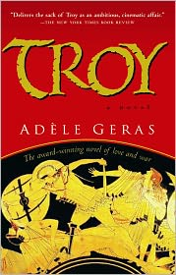
South Miami Senior High School
Summer Reading Assignment
2015
9th Grade, English I

  - Summer Reading Assignment

Over the summer, you will be reading Troy by Adele Geras. Aside from reading the novel, you will be responsible for completing a Book Brochure based on the novel. The Book Brochure will be collected the first week of school. This assignment will be your first two grades for the first grading period.

BOOK BROCHURE Directions: Fold a sheet of paper so it has three columns.
You should have 6 sides.

Front cover:
Title/Author, Illustrate Personal Book Cover (Not the one on the book),
Name and Period

Back cover: Summary/Critique of the book (About three paragraphs. Use quotes and details to support your ideas.)

You must also include the following in the other four sections:

* Four significant quotes from the book, and explanations of why each quote is significant.

* Character Descriptions- (Choose 3 characters) How do they behave? What do they do? How do they look? Explain each one.
The siege of Troy has lasted almost ten years. Inside the walled city, food is becoming scarce and the death toll is rising. From the heights of Mount Olympus, the gods keep watch.
But Aphrodite, goddess of love, is bored with the endless, dreary war, and so she turns her attention to two sisters: Marpessa, who is gifted with god-sight and serves as handmaiden to Helen, the most beautiful woman in the world; and Xanthe, who is kind and loving and tends the wounded soldiers in the Blood Room. When Eros fits an arrow to his silver-lit bow and lets it fly, neither sister will escape its power.
With vitality and grace, Adèle Geras breathes personality, heartbreak and humor into this classic story, told through the eyes of the women of Troy.

* Setting- Where does the story take place? In what ways is the setting important?

* Ten high school level vocabulary words with the definition and page number.

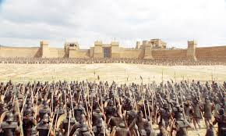
GRADING:

You will be graded on creativity, accuracy and use of information from the novel, presentation and conventions. You are encouraged to use graphics and illustrations to enhance your brochure.
 | Excellent | Satisfactory | Below Satisfactory
Creativity | Student work is original, unique, and shows great effort. | Student work shows some effort; however, it looks standard and expected. | Brochure is dull, and creativity cannot be distinguished.
Accuracy of Information | Brochure was created with specific and appropriate examples, quotes, and details from the novel. | Brochure has enough facts and details to create a few visual images and support student writing. | There are no examples, quotes, or details from the book. Information may be incorrect.
Presentation | Colorful, interesting, neat, contains graphics, obvious that student gave careful attention to detail. | Some color, typed, but minimal graphics and no extra effort in final draft. | Work is complete, but with minimal effort in the final draft. Looks like the rough draft.
Conventions | Student work demonstrates excellent use of the basic conventions, including punctuation, capitalization, sentence formation, and spelling. | Student work contains a few grammatical errors. Inconsistent use of correct punctuation, capitalization, sentence formation, and spelling. | Student work has frequent and severe errors in conventions. Writing has barely met requirements.

Additional assignments related to this novel will be given in class during the first week of school.
This assignment will be worth at least TWO GRADES; please do not take it lightly!
Due: Thursday, August 27th and Friday, August 28th
For questions or concerns, email calvarez@dadeschools.net.

